Curriculum Vitae
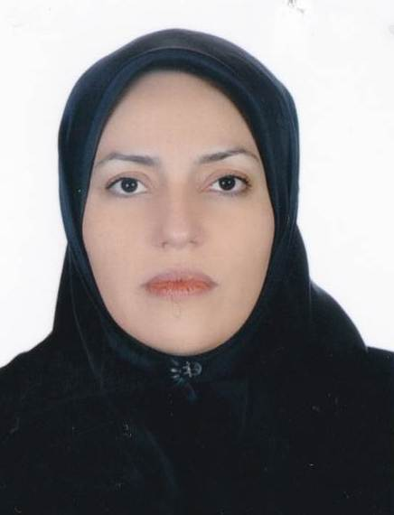

Name: Parvin
Last Name: hakimi
Address: ALzahra hospital, Artesh street,Tabriz, Iran

Phone: 00989144081356
E-mail: Parvin.hakimi56@gmail.com

Sex and Marital Status: female-married

Birth Date: 1356/06/06

Education:
1375-1382 Tabriz University of Medical Sciences, graduated as general practitioner.
1386-1390 Tabriz University of Medical Sciences, resident of Obstetrics and Gynecology.
1394-1395 Tabriz University of Medical Sciences, fellowship of Infertility and IVF
Licensure: Medical council, IR number: 96160

Honors/Achievements:

Academic Positions:
Assistant professor, Department of obstetrics & gynecology, Tabriz university of medical sciences

Teaching Experiences:
Clinical Mentor/ Instructor, of midwifery /clerkship /internship medical students /residents of obstetrics & gynecology/ fellowships of maternal fetal medicine.
Attending physician, inpatient & clinic patients’, Department of obstetrics &gynecology, Tabriz university of medical sciences, Alzahra- Taleghni hospital

Administrative Experiences:
1392-1394 Director of labor and delivery ward, Mahalati hospital

Research Interest:
Infertility , recurrent pregnancy loss, repeated implantation failour, colour dopler sonography

Publications in International Journals:
Abdolmohammadi Vahid, Samaneh, Mahnaz Ghaebi, Majid Ahmadi, Mohammad Nouri, Shahla Danaei, Leili ‎Aghebati‐Maleki, Reza Mousavi Ardehaie, Bahman Yousefi, Parvin Hakimi and Mohammad Hojjat‐‎Farsangi. "Altered T‐Cell Subpopulations in Recurrent Pregnancy Loss Patients with Cellular ‎Immune

Azar, Zahra Fardi, Parvin Hakimi, Morteza Ghojazadeh and Fatemeh Ghatresamani. "Pre-and Post-‎Mcdonald Cerclage Cervical Length, Width and Funneling Rate and Their Association with Duration ‎of Pregnancy." Pakistan Journal Of Biological Sciences 14, no. 8 (2011): 502.‎ Abnormalities." Journal of cellular physiology 234, no. 4 (2019): 4924-4933.

Hamdi, Kobra, Laya Farzadi, Alea Ghasemzadeh, Nazli Navali, Simin Atashkhoei, Helen Pia, Vahedeh ‎Shahnazi, Amir Fattahi, Zahra Bahrami-asl and Farnaz Sepasi. "Comparison of ‎Medroxyprogesterone Acetate with Cetrotide for Prevention of Premature Luteinizing Hormone ‎Surges in Women Undergoing in Vitro Fertilization." INTERNATIONAL JOURNAL OF WOMENS ‎HEALTH AND REPRODUCTION SCIENCES 6, no. 2 (2018): 187-191.

Hamdi, Kobra, Helen Pia, Parvin Hakimi and Parastoo Chaichi. "Relationship between Thickness and Pattern ‎of Endometrium and Pregnancy Rate in in Vitro Fertilization-Intracytoplasmic Sperm Injection ‎Cycles." (2018).

Latifi, Z, HR Nejabati, A Ranjbaran, T Ghasemnejad, K Hamdi, H Hajipour, N Raffel, Z Bahrami-Asl, P Hakimi ‎and A Mihanfar. "Association of Follicular Fluid Levels of Adrenomedullin 2, Vascular Endothelial ‎Growth Factor and Its Soluble Receptors with Icsi Outcome." In 34th Annual Meeting of the ‎European-Society-of-Human-Reproduction-and-Embryology (ESHRE), 33, 305-306, 2018.

Latifi, Zeinab, Hamid Reza Nejabati, Sina Abroon, Aynaz Mihanfar, Laya Farzadi, Parvin Hakimi, Hamed ‎Hajipour, Mohammad Nouri and Amir Fattahi. "Dual Role of Tgf-B in Early Pregnancy: Clues from ‎Tumor Progression." Biology of reproduction, (2019).

Ranjbaran, Ali, Hamid Reza Nejabati, Tohid Ghasemnejad, Zeinab Latifi, Kobra Hamdi, Hamed Hajipour, ‎Nathalie Raffel, Zahra Bahrami-asl, Parvin Hakimi and Aynaz Mihanfar. "Follicular Fluid Levels of ‎Adrenomedullin 2, Vascular Endothelial Growth Factor and Its Soluble Receptors Are Associated ‎with Ovarian Response During Art Cycles." Geburtshilfe und Frauenheilkunde 79, no. 01 (2019): 86-‎‎93.‎
‎
‎
‎

‎

‎

Publications in Iranian Journals:

Conference presentations (International):

• Follicular fluid Plgf/Sflt-1 ratio and soluble receptor for advanced glycation end–products correlate with ovarian sensitivity index in women undergoing A.R.T., The 4th International Congress on Reproduction, (Tehran 2018)

• Prostaglandin E Pathway in Uterine Tissue During Window of Preimplantation in Female Mice Mated with Intact and Seminal Vesicle–Excised Male, The 4th International Congress on Reproduction, (Tehran 2018)

• Association of follicular fluid levels of adrenomedullin 2, vascular endothelial growth factor and its soluble receptors with ICSI outcome, ESHRE 2018, (Barcelona 2018)

Research Projects:

Books Translated (English to Farsi):
راهنمای اموزشی معلمین برای پیشگیری از ایدز(ویژه دانش اموزان دوره راهنمایی و دبیرستان)

Supervision of Thesis:

Advisor of Thesis:

Skills:
- Surgery
- Education
- Research

Member of Associations:
Member of European society of Human Reproduction and Embrology(ESHRE)

